Gymnastics for All
East Midlands Regional
Competition Handbook

Event Organiser: East Midlands GfA Committee

About
East Midland Gymnastics Association
Our aim is to provide gymnastics opportunities for all ages and abilities across the East Midlands.
The region is made up of 5 counties starting in the North with Derbyshire, then into Nottinghamshire across to Lincolnshire, then down to Leicestershire, and finally finishing with Northamptonshire in the South.
The EMGA accounts for one of the 10 regions that form the English Gymnastics Association that in turn is the regional arm of British Gymnastics. We work as one organisation to provide opportunity and development for our sport both regionally, nationally, and internationally.
To help the region function we have a regional exec team consisting of a Chair, a Treasurer, Secretary and Regional Welfare officer. In conjunctions with the exec there is the BG development team consisting of an Area Manager and several representatives to support clubs. The development team actively work with the regions clubs to ensure we can help our clubs and disciplines meet the demand of our customers, now and in the future.

British Gymnastics
British Gymnastics is proud to be the UK Governing Body for the sport of Gymnastics. We exist to support, lead, and inspire all those involved or interested in Gymnastics.
British Gymnastics provides a national directive and structure for the sport; delivering a range of opportunities across the age spectrum to take part and stay in gymnastics, as well as developing talent and delivering top-level success.
The British Gymnastics strategy aims to meet the following vision and core purpose:
- Gymnastics is a passion shared by millions.
- To create and inspire lasting success for Gymnastics.
Contents
About 1
Section A – Overview 4
1.0 – Event details 4
1.01 – Who can enter? 4
1.02 – Time and dates 4
1.03 – Theme 5
1.04 – Entry fees: Gymnasts, Spectators, and Judges 5
1.05 – Entry and Payment method 6
1.06 – Key contacts 6
Section B – Details 8
2.0 – Entry details 8
2.01 – Late entries 8
2.02 – Changing of an entry detail 8
2.03 – Withdrawal of an entry detail 8
2.04 – Confirmation of entry 9
3.0 – Structure and programme 9
3.01 – Type, level, and pathway 9
3.02 – Confirmation of programme 9
3.03 – Overview programme structure 10
3.04 – Category breakdown 10
3.05 – Eligibility requirements 11
3.06 – Training hours 12
3.07 – Event adaptations 12
3.08 – Disability Gymnasts: Category classification 13
3.09 – Lining up, travelling, and presenting 13
3.10 – Awards, gifts, and celebrations 14
4.0 – Performance details 14
4.01 – Warmup 14
4.02 – Music requirements 15
4.03 – Skill requirements and Tariff sheets 16
4.04 – Apparatus 16
4.05 – Repetition of elements 17
4.06 – Missing elements 17
4.07 – Restarting 17
4.08 – Deductions 18
4.09 – Judge slip example 18
4.10 – Appeals & inquiries 19
5.0 – Club, School, and Leisure Centre requirements 19
The following table provides information on the level of British Gymnastics membership each gymnastics environment 19
6.0 – Role requirements 20
Section C – Venue & Governance 23
7.0 – Venue facilities 23
7.01 – Access/ egress 23
7.02 – Catering 23
7.03 – Toilet and changing facilities 23
7.04 – Hygiene & sanitisation 23
7.05 – Car parking 24
8.0 – Regulations 24
8.01 – Standardisation 24
8.02 – Code of Behaviour 24
8.03 – Spectating the event 24
8.03.1 – Ticket purchasing 24
8.03.2 – Event entry 25
8.03.3 – Behaviours during the event 25
8.03.3 – Crowd imagery 25
8.04 – Photography 25
8.05 – Feedback and complaints 26
8.06 – Health and safety 26
8.06.1 – Health & Safety statement 26
8.06.2 – Risk Assessments 26
8.06.3 – Adaptations 27
8.06.4 – First Aid and Welfare 27
8.06.5 – Allergies 27
8.07 – Emergency procedure 27
8.08 – Privacy statement 28
8.09 – Terms and conditions 28

Section A – Overview

1.0 – Event details
Welcome to the East Midlands Gymnastics Competition Handbook.
The aim of this gymnastics event is to provide opportunities for gymnasts to participate within a fun and non-pressurised environment.
Each event is designed to support gymnasts mentally and physically develop to a stage of their ability through their chosen gymnastics discipline pathway, starting at inter & intra club event through to county & regional events.

1.01 – Who can enter?
Gender | Boys and Girls (see specific event)
Age | 5+ years  Following the guidance set out British Gymnastics in the Health & Safety Guidance: Coaching Practice, gymnasts must be of age to enter the appropriate category, on the date of the event.
Ability | This event is aimed at gymnasts training a maximum of  1 – 4 hours per week.
Club, County, Region | This is open to all British Gymnastics registered clubs who are affiliated to East Midlands Gymnastics Associations (EMGA).
Type of event | These events are Live events with spectators.
Notes:
- Specifics of categories are in Section 3.04 Category breakdown.
- Specifics of participant requirements are in Section 3.05 Eligibility requirements.

1.02 – Time and dates
Event Dates for 2022 | Competition: | Level: | Location:
22 May 2022 | 3 Piece Festival Under 8’s Years | 8s and under | Amber Valley Gymnastics Club  Unit 2 Asher Lane, Pentrich,  Ripley,  Derbyshire,  DE5 3SW  Google link
12th June 2022 | 4 Piece Primary 2 and Primary 1 | Primary 2  (all ages)  Primary 1  (all ages) | Amber Valley Gymnastics Club  Unit 2 Asher Lane, Pentrich,  Ripley,  Derbyshire,  DE5 3SW  Google link
26th June 2022 | 4 Piece Adv, Adv+, Adv+ Challenge | Advanced  (all ages)  Advanced Plus  (all ages)  Advanced Plus Challenge  (all ages) | Amber Valley Gymnastics Club  Unit 2 Asher Lane, Pentrich,  Ripley,  Derbyshire,  DE5 3SW  Google link
16th October 2022 | Floor and vault Festival 8s years and under | 8 and under | Erewash Valley Gymnastics Club  Hallam Fields Road, Ilkeston,  DE7 4AZ  Google link
6th November 2022 | Floor and Vault Primary 2 and 1 | Primary 2 – Girls  Primary 1 – Girls | Erewash Valley Gymnastics Club  Hallam Fields Road, Ilkeston,  DE7 4AZ  Google link
13th November 2022 | Floor and Vault  Adv, Adv+, Adv+ Challenge | Advanced  (all ages)  Advanced Plus  (all ages) | Erewash Valley Gymnastics Club  Hallam Fields Road, Ilkeston,  DE7 4AZ  Google link

Notes:
- The Event Organiser holds the right to close the entry period early if the maximum entries have been reached.
- The start/ end times are subject to change pending receipt of entries and programme creation. Enhancing your experience is vital, please be patient with the Event Organiser.
- For local services, check with service provider prior attendance as these may vary from day-to-day,.

1.03 – Theme
Event theme: | No themes for any of these events.

1.04 – Entry fees: Gymnasts, Spectators, and Judges
Per gymnast: | Floor & vault – £12.50  3-piece festival or 4-piece events – £15.00
Notes:
- Fees to be submitted via representing club only.
- Upon entering this event, gymnasts agree to the Code of Behavior – Gymnasts terms.

Cost per spectator: | Adult  (15+ years) | Child  (Under 14 years) | Infant  (Under 2 years)
 | £5.00 | £0.00 | £0.00
Notes:
- Seating is limited and fees are to be paid on the day of the event.
- Upon attending the event, spectators agree to the Code of Behavior – Spectators terms.
Judge requirement: | See Section 6.0 Role requirements
No allocated judge fee:  (Per club) | No judge = No entry
No show judge fee:  (Per judge) | £75.00
Notes:
- Judge courses can be found on the British Gymnastics Courses page.
- Judge levy fee to be communicated with the Event Organiser prior payment.
Required as part of entry: | Volunteers | Display group or individual to perform between rounds
 | One | N/a
Note:
- See Entry Form for further details.
Please state on the Entry Form anyone requiring additional requirements, to allow the Event Organiser/ Host Club the opportunity to discuss and act as reasonably practicable to cater for your requested adaptations.

1.05 – Entry and Payment method
Entry method: | British Gymnastics online entry system (GymNET)  See specific event for entry system link
Entry opening date: | Estimated 2 calendar months prior to event date  (see Find an Event for specifics)
Entry closure date: | Estimated 1 calendar months prior to event date  (see Find an Event for specifics)
Payment due: | Upon entry via GymNET.

Notes:
- Without final payment, entry will not be completed.
- The Event Organiser holds the right to close the entry period early where the maximum number of entries have been achieved.

1.06 – Key contacts
Event Organiser: | Susannah Watts | Email only | eastmidsgfa@gmail.com
Vice chair | Alex Shaw | Email only
Committee Member: | Jo Robb | Email only
Committee Member: | Jo Shaw | Email only
Committee Member: | Danielle Humenko | Email only
Welfare Officer:
Safety Officer:
Covid Officer:
Keeping in ‘the loop’:
- Updates for this & future events – EMGA have a Facebook page:
- Ongoing event updates – Follow your local and surrounding British Gymnastics Regional Facebook pages:

Section B – Details

2.0 – Entry details
This section details are in addition to those within Section A – Overview.

2.01 – Late entries
Late entry fee: | £18.00
Notes:
- If you believe your entry will be late, please contact the Event Organiser to discuss your situation.
- Cases are taken on individual basis.

2.02 – Changing of an entry detail
Events are complex occasions and changes happen due to unforeseen circumstances such as injuries, illnesses, or sudden happenings. Depending on the stage of the will require the following action to complete a change in entry detail (i.e., gymnast, coach, spectator etc.):
 | Entry created & not paid yet. | Entry submitted & have paid.
Before the entry date closure: | - Amend your entry.  - Pay to confirm/ submit. | - Email the Event Organiser with details of the changes.  - Await confirmation prior any additional fee payments.
After the entry date closure: | - Email the Event Organiser with details of the changes.  - Await confirmation prior any additional fee payments.
Notes:
- The Event Organiser reserves the right to refuse changes depending on stage of event organisation.
- Where change request is accepted, an updated Entry Form maybe requested.

2.03 – Withdrawal of an entry detail
To withdraw a gymnast please email the Event Organiser with the following details:
- Full name
- DOB
- Membership number
- Category – Level and Age
- Reason for withdrawal
 | Before entry submission. | Before the closure date. | After closure date.
Fees to withdraw: | No fee has been charged. | No fee will be charged as part of consumer rights. | Full cost of the entry fee.
Notes:
- The Event Organiser will require the original bank details for refunds to be processed.
- Withdrawal of other roles (Judges, Volunteers etc.) please email the Event Organiser.

2.04 – Confirmation of entry
Upon receipt of entry form, your will receive a confirmation of payment and date requirement.
Upon payment of entry, you will receive a confirmation to complete your entry.

3.0 – Structure and programme

3.01 – Type, level, and pathway
Event type: Gymnastics for All
Event level: Under 8’s to Primary 2 to GfA Adults
Event pathway: The following diagram provides an overview pathway for events.

This following diagram provides an overview pathway for EMGA events:

For Pathway and Performance specific pathway requirements, see the:
- British Gymnastics Technical pages.
- Regional and Home Countries pages.
Section 3.05 Eligibility requirements regarding specific entry levels requirements.

3.02 – Confirmation of programme
Upon entry closure date, the final programme will be circulated by the Event Organiser.
Not received the programme yet
If you have not received by the date stated within Section 1.02 Time and dates, check your ‘Junk Mail’. If not received, contact the Event Organiser.
Found an error in the programme
If you have found an error in the programme, contact the Event Organiser.
If you have found an error in the results, see Section 4.10 Appeals & inquiries.
Have a change to the programme
See Section 2.02 Changing of an entry detail.

3.03 – Overview programme structure
Example Event: | Activity: | Estimated time:
Event 1 | Club arrival to event | 8:30am
 | Registration for Gymnasts, Coaches, Judges, Volunteers | 8:30am
 | Doors open for Spectators | 8:30am
 | Coaches and Judges briefing/s | 8:45am
 | General warm up for Gymnasts | 8:45am
 | Main event: including rounds, change overs, apparatus warmups, and intervals. | 9:00am
 | Gathering of results and result presentation | 11:40am
 | Event 1 ends | 12:00noon
Notes:
- The above times are estimate timings and all times will be confirmed upon entry closure.
- Where entries deem appropriate, a second event (e.g., an afternoon event) will be held.

3.04 – Category breakdown
Competition: | Categories: | Ages:
Floor and Vault  Under 8 Years | Under 8’s – Boys  Under 8’s – Girls | 5 Years  6 Years | 7 Years  8 Years
Floor and Vault Primary 2 and Primary 1 | Primary 2  Primary 1 | 8 years  9 Years  10 Years  11 Years  12 Years | 13 Years  14 Years  15 Years  16 Years
Floor and Vault  Adv, Adv+, Adv+ Challenge | Advanced  Advanced Plus  Advanced Plus Challenge | 10 Years  11 Years  12 Years  13 Years | 14 Years  15 Years  16 Years
Four Piece Primary 2 and 1 | Primary 2  Primary 1 | 8 years  9 Years  10 Years  11 Years  12 Years | 13 Years  14 Years  15 Years  16 Years
Four Piece Adv, Adv+, Adv+ Challenge | Advanced  Advanced Plus  Advanced Plus Challenge
Open to all Disability Gymnasts.

Additional category notes:
Age
- Depending on the number of category entries upon closing date, some are subject to change.
For example: 7 years category may become two groups; Jan – Jun born and Jul – Dec born.
The Event Organiser has this discretion and communicate prior upon programme circulation.
- Following the guidance set out British Gymnastics in the Health & Safety Guidance: Coaching Practice, gymnasts must be of age to enter the appropriate category, on the date of the event.

Level of gymnast
- Gymnasts are required to participate at the same level on all apparatus.
- As per the British Gymnastics Equality Policy, Clubs & Coaches have a responsibility to enter the gymnasts in at the most appropriate level and event to ensure all gymnasts gain a fair performance opportunity and to reduce the risk of mental or physical injury.
  - 8-year-old gymnasts can enter either the Under 8 Years competition or the Primary (and above) competitions. This is to allow a smoother transition during ability changes. The coach and gymnast are to decide this ethically.
Inclusion of all gymnasts
- These event rules are designed to be inclusive.
- Disability Gymnasts and gymnasts with additional needs are able take part in this event, further details are in Section 3.07 Event adaptations and 3.08 Disability Gymnasts: Classification.
- You can inform the Event Organiser of any category requirements & additional needs by contacting the Event Organiser.

3.05 – Eligibility requirements
Gymnasts are eligible to enter into any of the levels outlined in Section 3.04 Category breakdown, with the considerations of the gymnasts mental & physical wellbeing. The below requirements help to provide a fair performance opportunity for gymnasts:
Gymnasts that have: | Are to enter at the following level/s:
Entered Artistic Floor & Vault Competitions | Not eligible to enter this event.
Entered GfA Floor & Vault competitions and won a medal | Move up to the next level the following year.
Entered GfA 4-Piece competitions and won a medal | Move up to the next level the following year.
Entered Artistic County or Regional Four Piece Competitions zinc or above or Regional/ National Grades and/ or Tumbling National 1 | Not eligible to enter this event.
Competed at Club Grades 6 and 5 | Can enter as long as they are upkeeping to the maximum training hours – See section 3.06.
Been a former Artistic Gymnast | Must not have competed for one year and must enter the advanced levels.

3.06 – Training hours
Maximum training hours per week:
 | Primary 2 | Primary 1 | Advanced | Advanced Plus | Advanced Plus Challenge
Girls | Four | Four | Six | Six | Six
Boys | Four | Four | Six | Six

Note:
- As part of an equitable event, this guidance is in place for each category/ level and apply to individual gymnasts, including all their training hours despite their gymnastics discipline.

3.07 – Event adaptations
Event specific support and/ or adaptation:
This event supports all those involved in their role (gymnast, judge, coach, spectators etc.), to ensure that the event is successful and aligns to British Gymnastics policy & guidance. While this event has specific criteria (entering, judging, code of behaviour etc.) there are adaptations which can be authorised to support those involved in a reasonably practicable way.
Attendees of this event requiring support and/ or adaption should include this as part of the Entry Form process.
Every individual’s request is taken on a case-by-case situation for equality purposes. Requests are required to be submitted to the Event Organiser a minimum of 10 working days prior to the event date.
British Gymnastics support:
All British Gymnastics recognised events are focused as inclusive by follow such policies/ guidance’s as the:
- Equality Policy
- Clothing at Event Policy
- Advertising on Competition Clothing Attire at Events Policy
- Policy on the Participation of Trans People in Gymnastics Competition
Inclusion is continuous and where any discrimination against any of the protected characteristics is heard or seen, it is to be reported to the Event Organiser, or another member of staff straight away to be acted upon.
See sections 8.09 Terms and conditions and 8.02 Code of Behaviour further details.

3.08 – Disability Gymnasts: Category classification
Gymnasts may already have a British Gymnastics Classification Certificate (details found on Club Hub Resources). Although, as defined by the HSE.gov.uk/disability (Oct 2021) & the Equality Act 2010, gymnasts who have a physical or mental impairment that has a substantial and long-term negative effect on their ability to do normal daily activities, are able to enter this event with reasonable adaptations.
This diagram helps gymnasts initially self-categorise for this event, with the provisional options. Therefore, helping to identify the individuals wishes & need/s e.g., does the gymnast wish to enter into a ‘Disability’ category or an ‘Integrated’ category for this event.
Notes:
- The Entry process will ask for the most appropriate classification(s) of the gymnasts’ disability (email Event Organiser).
- Depending on the number of category entries upon closing date, some categories are subject to change.
- For information on inclusion and the registering an official classification for pathway events, see the Club Hub – Resources (Inclusion).

3.09 – Lining up, travelling, and presenting
Presenting:
As part of competition etiquette, gymnasts and officials will present at specific times, including:
- At the start of the event – often done as a team.
- Before & after their performance – particular to signal the start/ end of performance.
- During the ceremony – often as a team and upon individual awards.
Lining up:
For swift movements between rounds/ events, coaches are to ensure gymnasts are prepared to move to their apparatus. This can be shown through an appropriate line up and gathering of personal belongings. An often-used approach is height order or performing order although this isn’t compulsory.
Travelling:
For safety & safeguarding reasons, there are allocated performers areas where only those involved in the event are allowed. Where a gymnast etc. requires exit/ entering this area they must speak with an event official first.
While travelling around the venue their allocated areas for each apparatus/ team, this is for safety and performance reasons.

3.10 – Awards, gifts, and celebrations
To celebrate individual success of gymnasts in categories (see Section 3.04 Category breakdown) the following awards, gifts, and celebrations are planned as part of this event:
(Note: these may alter depending on final entries etc.)

Every gymnast will receive:
Participation gift
Winning gymnasts will receive:
6th – 4th placed gymnasts – Certificate
3rd – 2nd placed gymnasts – Medal
1st placed gymnasts – Trophy & Medal

Age 8 and under festival gymnasts will receive:
These gymnasts will participate for gold, silver or bronze recognition. Every gymnast will be awarded a bronze, silver or gold medal based on their score. The winning gymnast in each age category will also receive a trophy.

4.0 – Performance details

4.01 – Warmup
General warmup:
All events include a general warmup at the beginning of the event which individual clubs/ coaches are to continue supervising their own gymnasts throughout, while stages maybe combined.
There isn’t a separate warmup hall for the gymnasts.
Apparatus warmup:
Each apparatus/ round includes an approximately 5 minutes warmup, although this table helps to breakdown individual timings per gymnast (approx.).
Maximum warm up time – Competition/ Apparatus
 | Primary 2: | Primary 1: | Advanced: | Advanced Plus: | Advanced Plus Challenge:
Floor | 5 mins | 5 mins | 5 mins | 5 mins | 5 mins
Vault | 2 mins | 2 mins | 2 mins | 2 mins | 2 mins
Beam | 45 secs | 45 secs | 1 min | 1 min | 1 min
A Bars | 1 min | 1 min | 1 min | 1 min | 1 min
High bar | 1 min | 1 min | 1 min | 1 min
Trampette | 1 min | 1 min | 1 min | 1 min
All timings will be communicated within the event program and are subject to change.

4.02 – Music requirements
Category music requirements:  (See Skills & Tariff sheet for requirement specifics) | - Advanced – Girls; Floor routine  - Advanced Plus – Girls; Floor routine  - Advanced Plus – Challenge; Floor routine

Music submission* date deadline: | As per closing date
Music submission* method: | Via GymNET
Music submission* format: | MP4/ MP3
To be brought on the day: (Format) | MP4/ MP3
*Music submission must include the:
- Club
- Gymnast full name/ team name
- Category.
Music licensing:
There are music licencing requirements placed on this event/ venue by PPL.
To use music in your recognised gymnastics environment, you require a PPL/ PRS licence. More information can be found at the PPL website.
You can check the permissions on your chosen music on the PPL website - music checker.
Walt Disney, Andrew Lloyd Webber, or Cirque de Soleil music isn’t permitted.
The Event Organiser isn’t liable for any damages for of music devices brought on the day, this the responsibility of the Club/ Coach.
There is gymnastics specific guidance on the Club Hub - Resources.
You may hear the organiser/ host venue playing music, this will also abide by the PPL/ PRS licencing laws.

4.03 – Skill requirements and Tariff sheets
Tariff sheets required for this event: | 0 tariff sheets
To be handed into: | N/A
Submission deadline: | N/A
Note:
- Skills requirements are found on the accompanying ‘Skills and Tariff sheet’ document.

4.04 – Apparatus
Apparatus | Specific use for: | Manufacturer | Size, dimensions, run up, landing details | Image
Sprung floor | All levels | GymNova | 12m x 12m  See competition specific requirements | 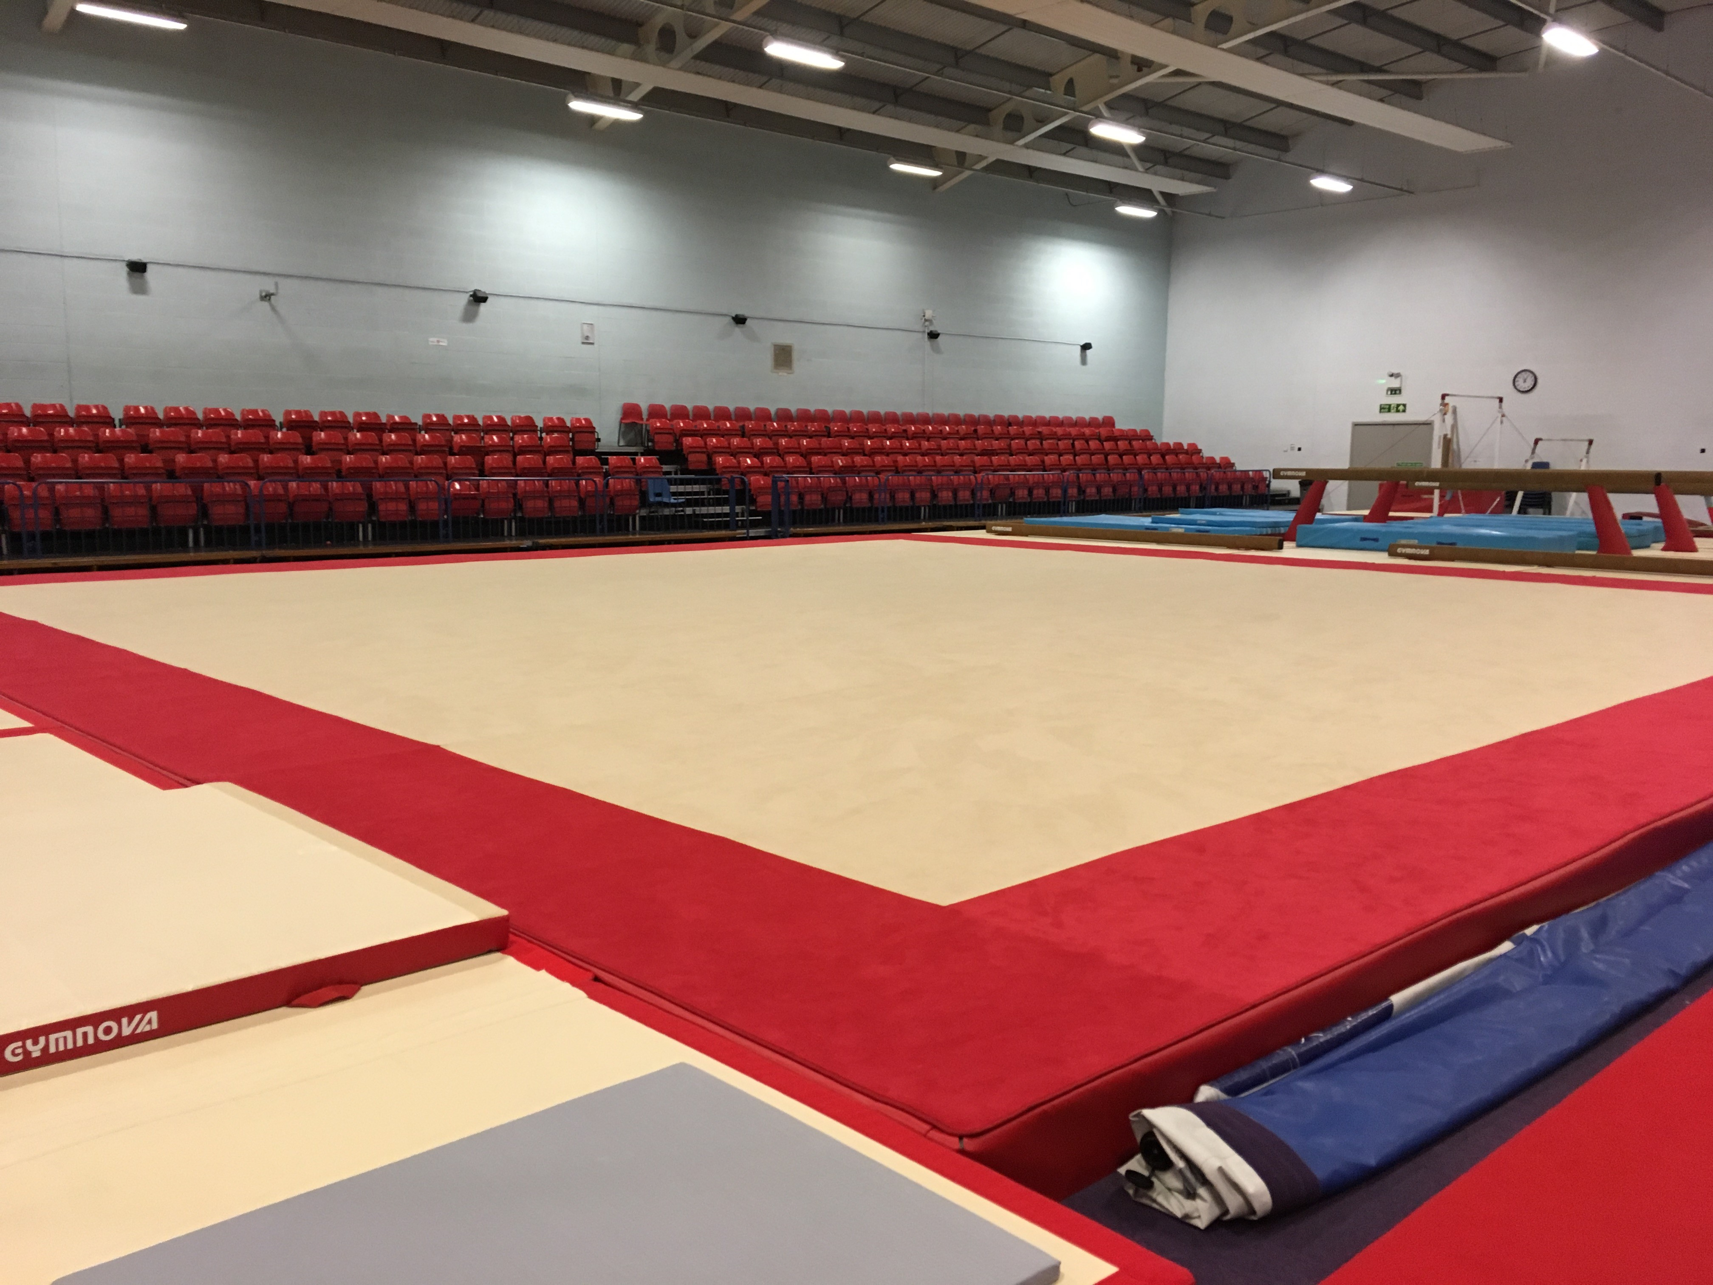
Red block  (Under 8 vault) | Under 8 Years | Generic | Height 100cm | 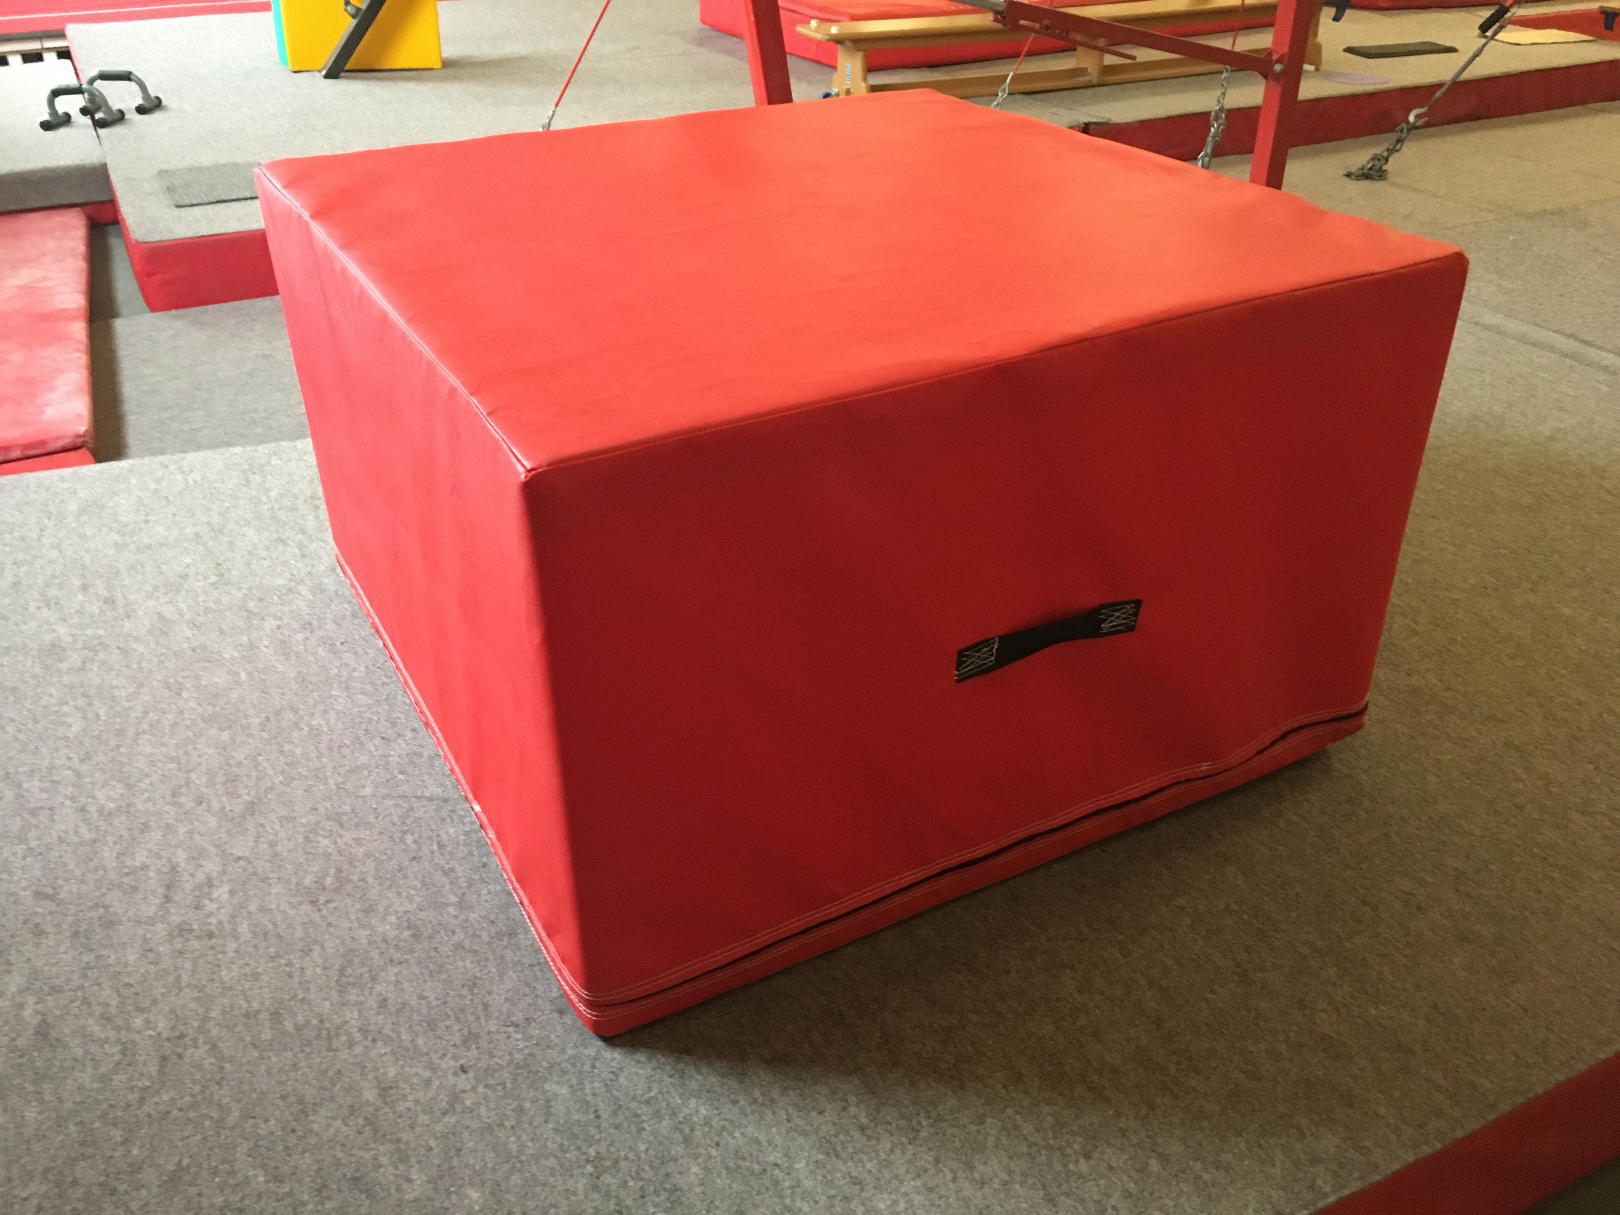
Bench | Under 8 Years | Generic | Single bench | To follow
Table vault | Primary 2  Primary 1  Advanced  Advanced Plus  Advanced Plus Challenge | GymNova | Height 100 – 165cm  See competition specific requirements | 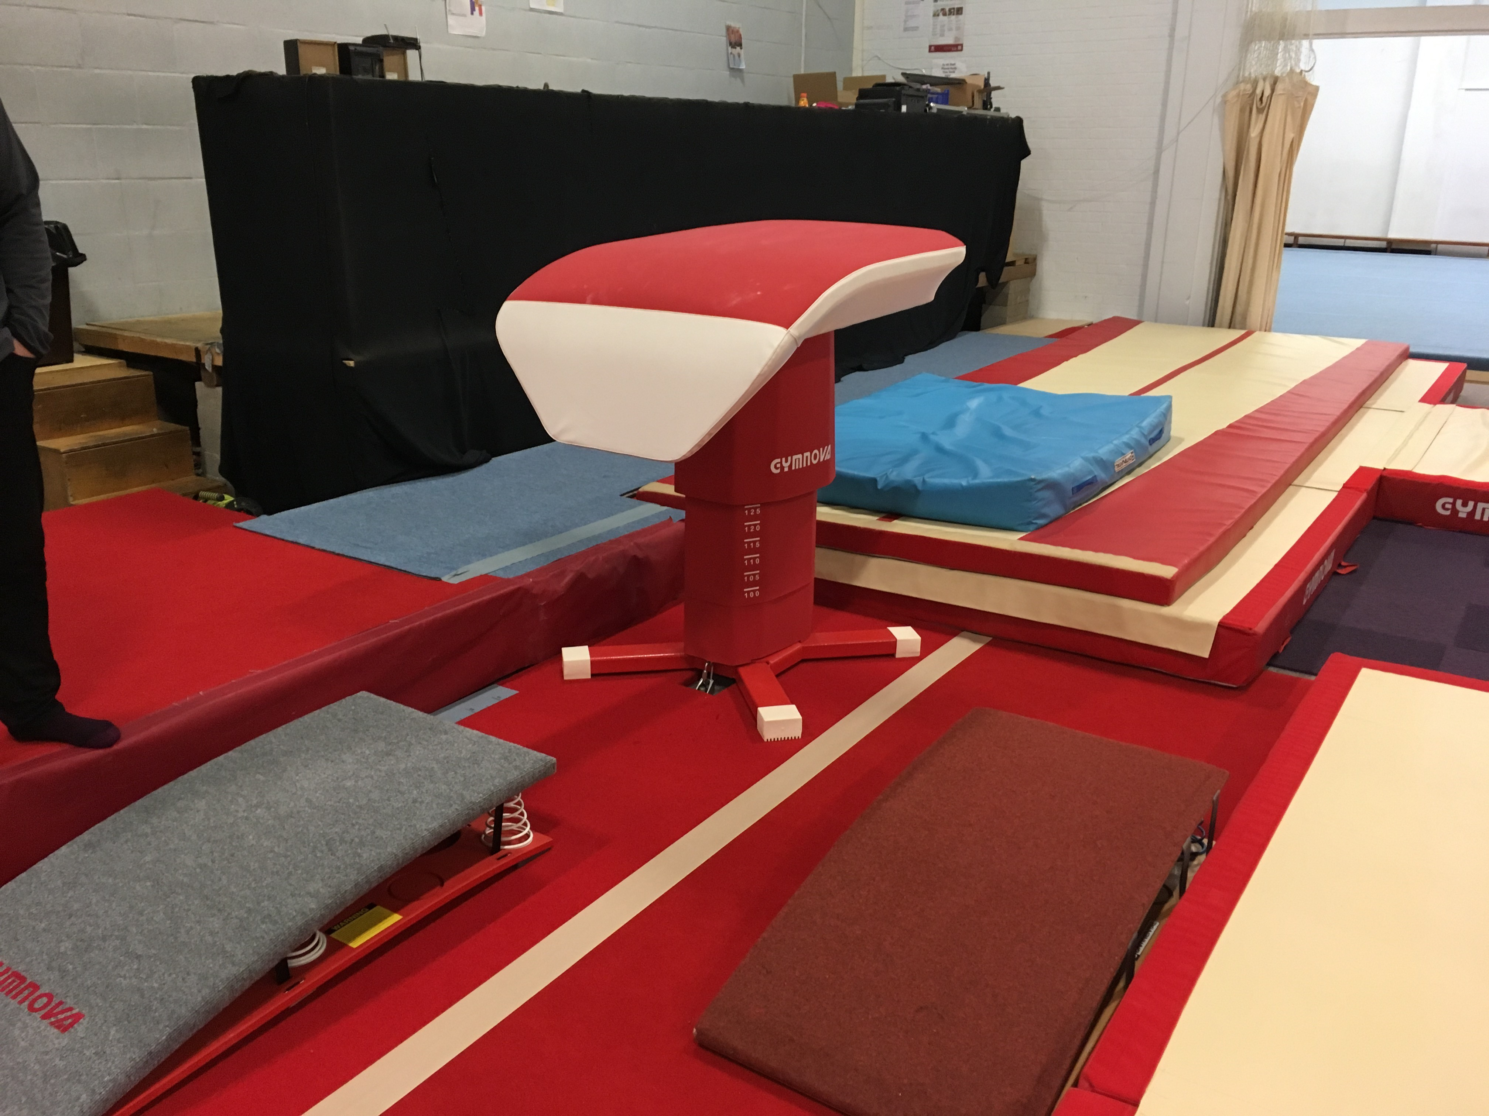
Beam | Girls Four Piece:  Primary 2  Primary 1  Advanced  Advanced Plus  Advanced Plus Challenge | GymNova | As per FIG Apparatus Norms brochure  Length: 500cm  Width: 10cm | 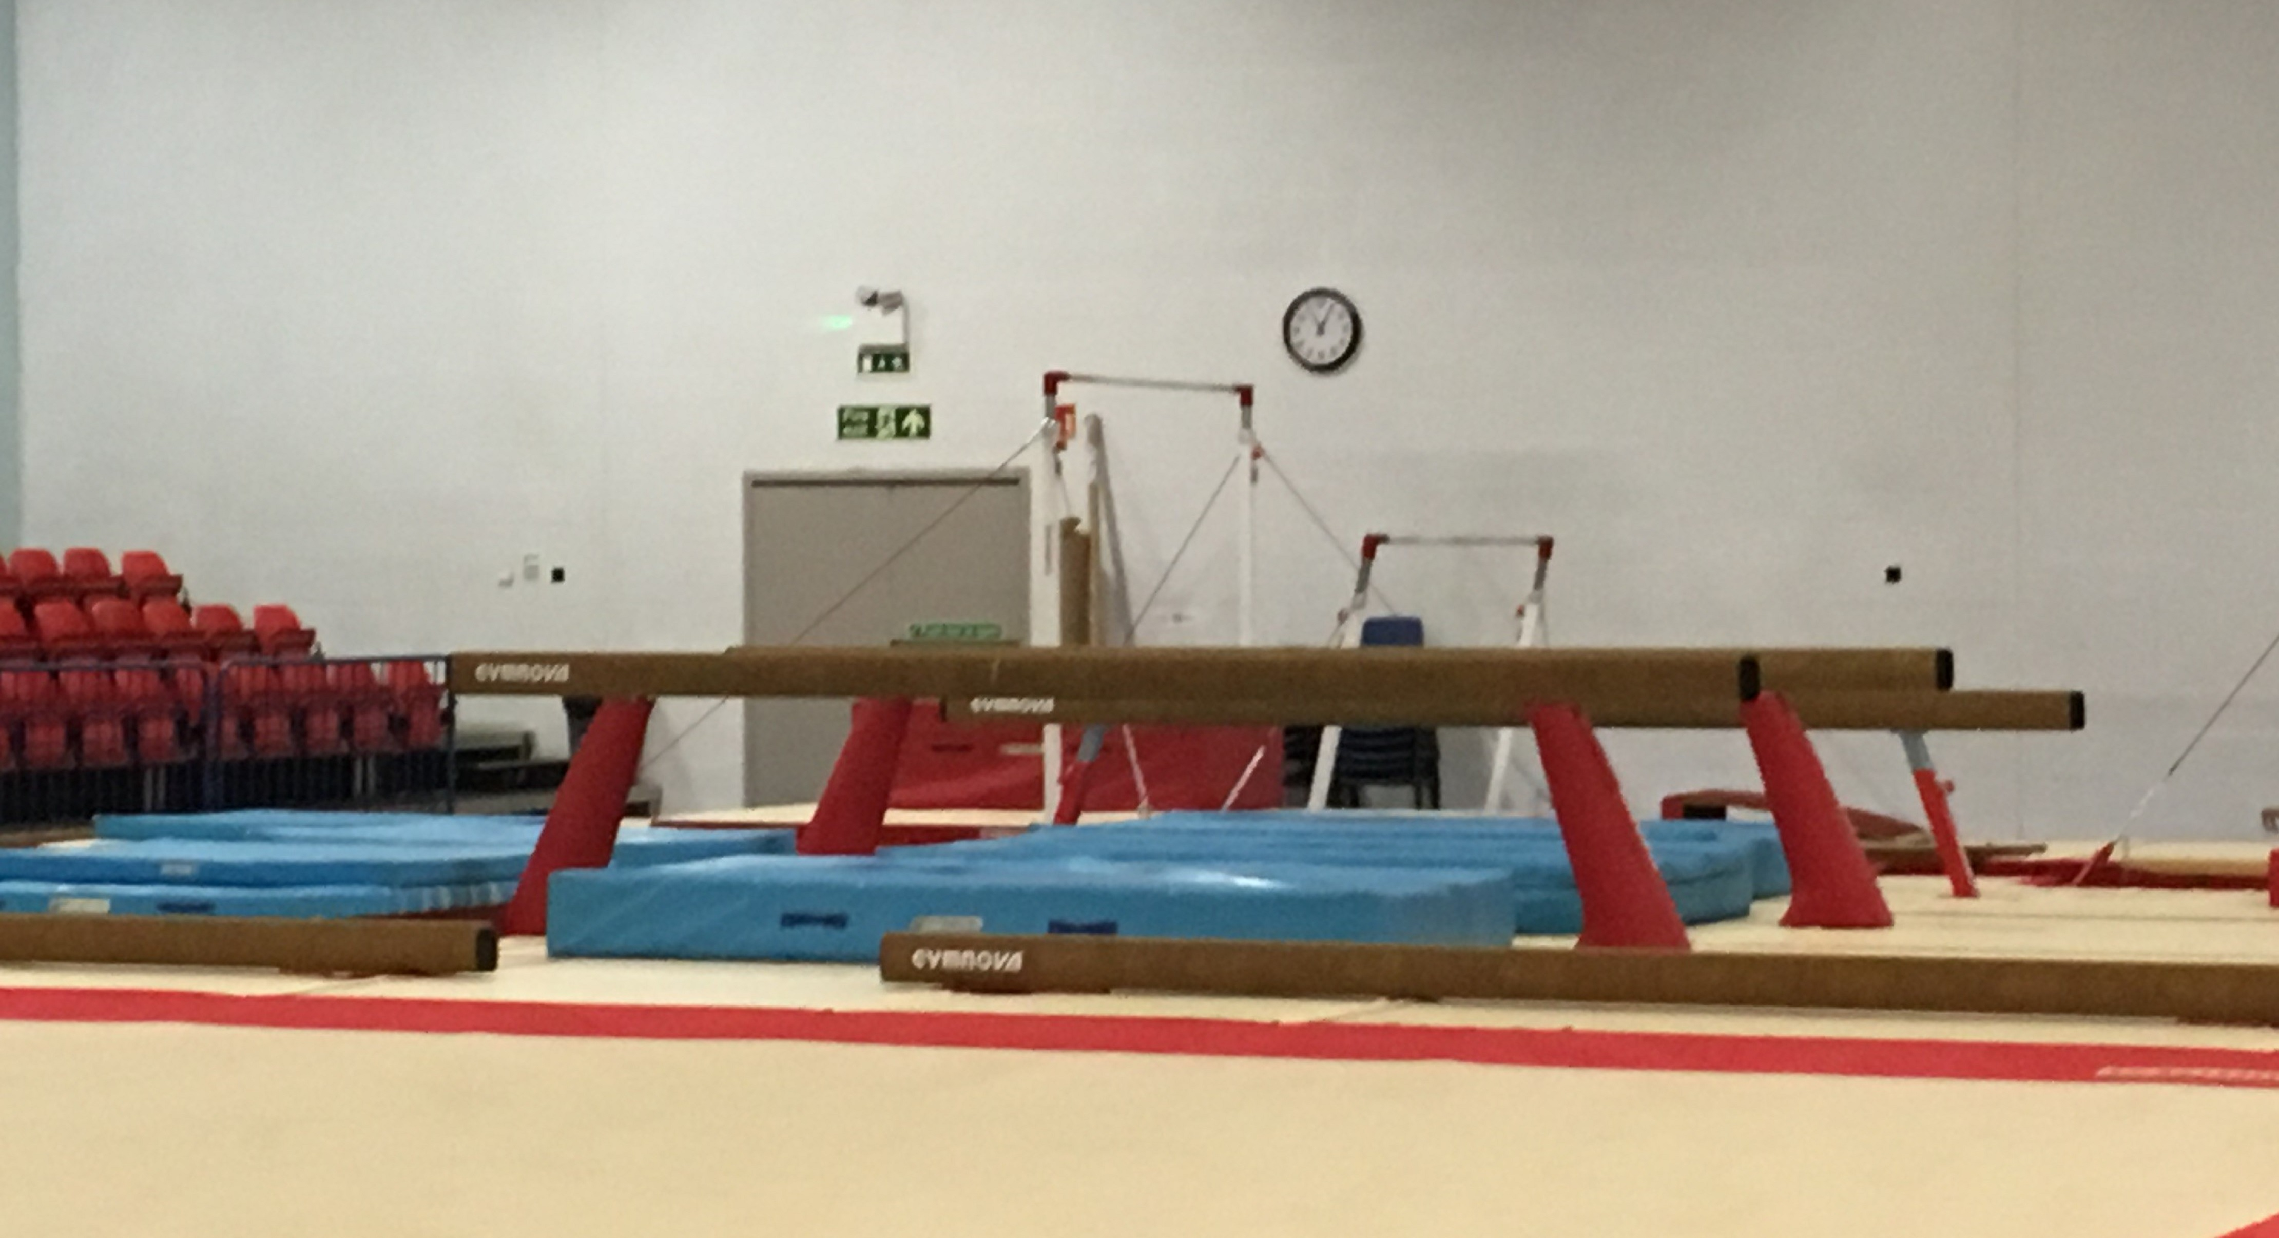
A Bars | Girls Four Piece:  Primary 2  Primary 1  Advanced  Advanced Plus  Advanced Plus Challenge | GymNova | As per FIG Apparatus Norms brochure  Height of bar: adjusted to suit gymnast  Distance between bars: min 130cm – 180cm max
H Bar | Boys Four Piece:  Primary 2  Primary 1  Advanced  Advanced Plus | GymNova | Can be adjusted by coach to suit the gymnast | 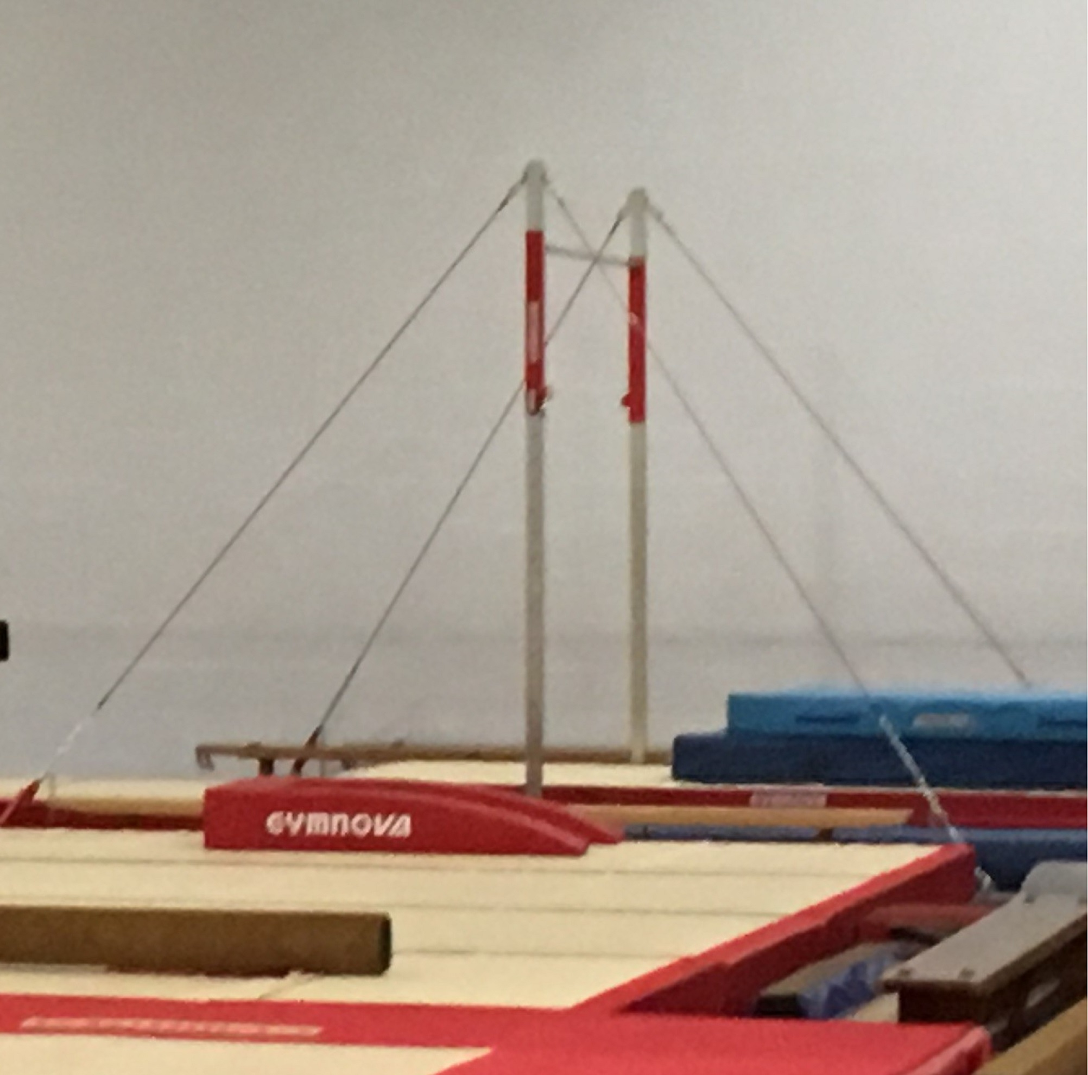
Trampette | Boys Four Piece:  Primary 2  Primary 1  Advanced  Advanced Plus | GymNova | 1.1m x 1.1m  Can be adjusted by coach to suit the gymnast | To follow
Notes:
- The above details are those which are specified for the event, it is advisable to prepare using the dimensions for the appropriate level.
- Where any changes are made upon event day, the organiser will inform all entered clubs. For any specific questions, contact the Event Organiser.

4.05 – Repetition of elements
See accompanying Skills and Tariff sheet for details of specific skill requirements for each apparatus of this event. Where elements are repeated, they will not be counted and may gain deductions.

4.06 – Missing elements
Routines missing elements (skills) will receive a 0.5 deduction from the Judge(s).

4.07 – Restarting
To maintain an equitable balance, a restart individual’s routine (including re-ordering of group performances) of an is only allowed in situations where the judging panel feels this is fair to both the gymnast and the event (i.e., is it reasonably practicable to affect the event timings for that situation).
Factors they will consider, and are not limited to, are:
- Technological issues outside to the club & gymnasts’ control.
- Mental health.
- Factors outside the control of the gymnast.
Where gymnasts require to stop after initiating an element, supporting staff (coaches, organisers etc.) will assist in the safe stop and communication of next steps.

4.08 – Deductions
A guide on the deductions which the judges will be using within this event can be found in the ‘Skills and Tariff Sheets’.
There will be two judges on apparatus panel, where possible to ensure the flow and fairness of the event is maintained. The Competition Organiser will appropriately place the judges out in-line with their qualification and experience; this will also suit the categories applied to the competition.

4.09 – Judge slip example
Judging is vital part to events; this example judge slip provides an example how a judge will use a generic judging slip to calculate & record the score of an individual gymnast. Each events judging slips will vary depending on its requirements.
Example of judge’s deduction processing: *
Floor |  | X |  |  |  | Vault
No. | 101 |  | Gymnast name: |  | Forename. Surname.
This is based on the skills performed |  |  |  | DV score (including bonus’): |  |  | 2.5
 |  |  |  | C score: |  |  | 1.0
 |  |  |  | Execution starting score: |  |  | 10.00
DV score + C score + Execution starting score = |  |  |  | Starting score: |  |  | 13.5
What errors have they done against the requirements (max 10.0) |  |  |  | Execution deductions: |  |  | 3.6
Starting score – Execution deductions = |  |  |  | Final score: |  |  | 9.9
*These scores are for demonstration only

Nominating a judge:
Within Section 6.0 Role requirements it stipulates the requirements of judges for this event. Where you may know anyone that may be interested in judging there is:
- Judging Resource – Recreational Gymnastics, a useful initial resource before enrolling onto a judging course.
- Judging courses found on the Courses page.

4.10 – Appeals & inquiries
What can be appealed/ inquired?
The judge’s Execution deductions (score) are only those that can be appealed/ inquired against. All other scoring is set against the event criteria. Section 4.09 Judge slip example demonstrates this.
This is a friendly, low-pressure, fun event and we want to create a fair environment, this is a consideration as part of the appeal/ inquiry to strive the best possible outcome for all.
Who can submit the appeal/ inquiry?
All appeals/ inquiries can only be submitted by the Supervising/ Lead Coach named on entry form.
When does the appeal/ inquiry need to be submitted by?
Any appeals/ inquiries need to be submitted on the day of the event.
What needs to be included within the appeal/ inquiry?
The following needs to be included:
- Gymnast’s name and performance number.
- Apparatus performing.
- Error/ deduction being appealed/ inquired.
- What they believe is the ‘correct’ score and their reasoning.
Video evidence will not be accepted on any grounds.
With the above in writing please ensure it is executed in a constructive manner and not to breach terms with the Code of Behaviours stated in Section 8.02 Code of Behaviour.
Where to submit the appeal/ inquiry?
- During the event – Submitted to a Committee Member/ Competition Organiser.
- After the event – Submitted to the Event Organiser.

5.0 – Club, School, and Leisure Centre requirements

The following table provides information on the level of British Gymnastics membership each gymnastics environment
Environment | Club | School | Leisure Centre
Level of membership | BG Club membership | BG Club membership | BG Club membership
 | Further details can be found on the British Gymnastics website.
Affiliation | East Midlands Region | East Midlands Region | East Midlands Region
 | Further details on how to become affiliated can be found by emailing eastmidsgfa@gmail.com

6.0 – Role requirements
The following table provides requirements for Judges, Coaches, and Gymnasts that are involved within this event:
 | Judge | Coach | Gymnast | Volunteers
Numbers: | Minimum requirement =  1 – 10 gymnasts = X1 club judge.  11 – 20 gymnasts = X1 club and X1 Intro To… judges  No judge = no entry  No show judge = £75.00 fee | 1 coach: 8 gymnasts. | Maximum entry =  [Insert number] gymnasts per club. | Event requirement =  1 volunteer per club.
Qualifications |  | Responsible Coach  To be qualified in either:  GG, MAG, WAG  At a minimum of:  British Gymnastics recognised Level 2 | See Section 3.05 Eligibility requirements for details. | Role dependant.  Note: Volunteers aren’t qualified coaches, therefore unable to coach.
4-Piece Event: Responsible Coach
To be qualified in their specific apparatus discipline:
GG, MAG, WAG
At a minimum of:
British Gymnastics recognised Level 2
 | Ideal requirement =  Floor and Vault judge, Club level judge qualification in any of the following disciplines: Men’s Artistic, Women’s Artistic, TeamGym, Tumbling | Other Coaching Officials  To be qualified in either:  GG, MAG, WAG, TG, TUM  At minimum:  British Gymnastics recognised Level 1
DBS | No | Yes | No | Role dependant – More details on Club Hub – Resources.
Safeguarding training | No | Yes | No | Role dependant – More details on Club Hub – Resources.
Membership | Minimum requirement =  Up to & including Regional events – Bronze membership  National & Brevet - National Brevet membership | Responsible Coach =  Coach membership  Other Coaching Officials =  Coach qualification specific – More details on British Gymnastics website. | Recreational events =  Recreational Gymnast membership.  Pathway events =  Competitive Gymnast membership. | Role dependant  Minimum requirement =  Bronze Club Officer
 | More details can be found on the British Gymnastics membership webpage.
Experience and abilities | It is beneficial to have experience.  The use of online resources through the discipline specific courses (contact your discipline national technical committee for details). | Coaches must only delivery skills within their qualification syllabus.  For Regional/ National events coaches are able to use the Lead Coach Guidance. | Gymnasts only to perform elements which:  - They are competent and experienced at.  - Their Lead Coach is qualified within. | No experience required, only motivation in volunteering.
Attire | Minimum requirement =  Black trousers/ skirt, white shirt. | Suitably recognisable by all.  Appropriate to support/ spot gymnasts during practice and performances as required. | Clothing =  Tight fitting shorts, T-shirt, Leotard, Leggings, Leotards preferred if not shorts, matching gymnastic shorts may be worn but not cycling shorts. | General attire =  [Insert attire].
Hair =
Neat and tidy, tied back from the face.
 | Ideal requirement =  FIG standards – Navy trousers/skirt, white shirt | Further information found:  - Clothing at Events Policy  - Advertising on Competition Clothing Attire at Events | Feet =  Bare or gym shoes. | Provided attire =  [Insert attire].
Resting periods =
Additional suitable clothing on top during rest periods.
- Jewellery and Adornments
- Policy on the Participation of Trans People in Gymnastics Competition
Payment arrangements | It’s not the Host Club/ Event Organisers’ responsibility to financially support these roles in attendance of the event. |  |  | [Insert attire].
Transport arrangements | Each Club and Coach is responsible for organising and communicating the travel arrangements with all those involved.  Further information found:  - UK & Overseas Travel  - Health, Safety, & Welfare Guidance: Safe Trips
Notes:
- The Event Organiser has the right to withdraw any entry into the performance area where requirements aren’t met.
- British Gymnastics provide a range of continuous development on the Courses pages of the website, see Coaching, Judges, Club Roles, and CPD. Where you require further support on your role contact the Event Organiser.

Section C – Venue & Governance

7.0 – Venue facilities

7.01 – Access/ egress
Details such as the venue address etc. can be found in Section1.03 Venue and address.
This event includes the following accessibility facilities:
- Ramps
- Disability access
- Disability toilet/ changing
Anyone attending the event who may require support and/ or adaption should include this as part of the Entry Form process.
Note: The seats are made from a plastic, therefore if a softer seat is required for medical purposes, please inform the Event Organiser prior to the event.

7.02 – Catering
Available on-site
During this event there will be the following catering facilities available:
- Amber Valley – Café with hot & cold food served
- Erewash Valley – Café with cold refreshments
Arrangements for specific roles
These catering facilities are offered to the specific role in addition to the general event catering:
Gymnasts: | Coaches: | Judges: | Volunteers:
[Insert details] | [Insert details] | [Insert details] | [Insert details]

7.03 – Toilet and changing facilities
Both venues have limited toilet & changing facilities. Disabled toilet/ changing facilities are available.
Where possible, gymnast to arrive dressed ready to perform with additional clothing for warmth.
Section 7.04 Hygiene & sanitisation has additional information of cleanliness within these areas.

7.04 – Hygiene & sanitisation
British Gymnastics wish to support recognised events to ensure everyone’s health, safety, & welfare is maintained throughout. Levels of hygiene & sanitisation can vary for individuals, although following the ongoing guidance set out by the Government & British Gymnastics, for this event would like to encourage the following:
- [Insert details]
As per the Code of Behaviour and Section 8.02 Code of Behaviour this event abides by the Governments NHS Test and Trace system and asks anyone showing any of the listed symptoms (NHS symptoms) must stay at home and get tested.

7.05 – Car parking
While the event has been programmed to cater for the volume of car parking, there is the following car parking available:
- Amber Valley – There is plenty of free car parking available
- Erewash Valley – There is plenty of free car parking available. Use both the front and rear car park. On street parking also available.

8.0 – Regulations

8.01 – Standardisation
This event is recognised by British Gymnastics with the guidance of policies such as:
- Health, Safety, & Welfare Guidance: Safe Environment
- Health, Safety, & Welfare Guidance: Safe Participation
- Health, Safety, & Welfare Guidance: Safe Coaching Policy
- Health, Safety, & Welfare Guidance: Safe Trips Policy
- Safeguarding Policy
Using these policies & guidance, this event aims to provide a high quality & standardised approach to gymnastics for all those involved in the lead up & during the event.

8.02 – Code of Behaviour
Each gymnastics moment is a memorial; to create these such events, gymnastics can become challenging, competitive, & onerous on individuals. To ensure the mental and physical wellbeing of everyone involved these events are focused on fun & participation elements (‘friendlies’) therefore aren’t pressurised.
To ensure everyone encourages this philosophy throughout the event journey, the following are to be followed at all times:
- Code of Behaviour – Participant
- Code of Behaviour – Spectators
Where these aren’t followed the Event Organiser has the right to withdraw entry/ access to the event prior and during event, which may affect future attendance of events.

8.03 – Spectating the event

8.03.1 – Ticket purchasing
Tickets can be purchased via: | On the door
Tickets to be purchased by: | On the day
Notes:
- Spectators reserve the rights not to buy although a valid ticket must be held to spectate this event.
- Only valid ticket holders will be allowed access to the event.

8.03.2 – Event entry
Upon welcoming to the event, individuals will be asked:
- For proof of entry (ticket).
- To scan the NHS Test and Trace QR code. *
- [Insert additional requirements]

*Section 8.02 Code of Behaviour stipulates that this event abides by the Governments NHS Test and Trace system and asks anyone showing any of the listed symptoms (NHS symptoms) must stay at home and get tested.

8.03.3 – Behaviours during the event
As per Section 8.02 Code of Behaviour, everyone attending & involved in this event must enhance the experience through their behaviours. Any behaviours deemed unsatisfactory will have the related procedures taken to allow a fair and equal outcome.

8.03.3 – Crowd imagery
Experiencing the event in person is unique, sharing that moment with another is memorial. Therefore, during this event it is expected for imagery to be taken (full details found in Section 8.04 Photography) which those spectating may be included in the imagery background as a ‘crowd’ or specific ‘individual’ images. Section 8.08 Privacy statement demonstrates how this type of data may be used and is also stored.
Where any individuals aren’t able to have this photography taken, please inform the entering club who can then add this to their entry form, or upon day entry inform the staff member on the desk.

8.04 – Photography
It is your responsibility as the coach in charge of your entered team/club to be aware, and have records, of anyone that can/can’t have their photo/video taken for media purposes. If you have anyone that can’t, please ensure the Competition Organiser is aware prior to the date of the event so they can inform the appropriate persons so that any photography/ video of them is avoided. This can be done via emailing the Competition Organiser upon entry.
The following information is taken from the British Gymnastics policies and must be passed onto those who will be representing your club at this event, including spectators. At various points throughout the day the hosting club will also announce this information:
In the interests of child protection, photographs and video may only be taken during
today’s event in accordance with conditions set by British Gymnastics. Summaries of
these conditions are on display, and you can see a copy of the full conditions at the reception desk. Photos may only be taken for personal use. Unless specifically
accredited to do so, you may not take photos for sale, other commercial use or for
publication in printed or electronic form, such as on websites.
Some photos may be published by Clubs, but this may only be done in accordance with the British Gymnastics Child Protection Policy.
DE Photos will be on-site during many Regional GfA events to help capture each gymnasts’ special moments.
If you have any concerns about the identity or actions of any photographer or if you believe that any unsuitable photos are being taken, you should report your concerns to Welfare Officer/ Competition Organiser. In the interests of child protection please do let us know of anything that may be damaging to the welfare of a child.
The use of flash or supplementary lighting is not permitted while gymnasts are warming
up or competing. Please make sure that the flash is turned off on any device being used as your camera.
The use of live streaming is not permitted during any part of this event.
When ‘posting’ images on personal social media please ensure the following to reduce the risk of publication of the image (this isn’t the full list but key from the policy):
- Personal details are kept to a minimum – Use of their first name only etc.
- Suitable, sensible, and appropriate image taking/selection – Avoid such skills as splits and sensitive areas on the body
- Blur anyone else out of the image – Use technology to blur others out the image (if you can’t, don’t take/post the image)
If the Competition Organiser/Welfare Officer suspects inappropriate photography or filming, the Officer/ Organiser should exercise their powers under the conditions to request the person to leave the venue and to surrender any film and/ or delete any images relating to the event.

8.05 – Feedback and complaints
Events are set up with the sport at the heart, to allow ongoing improvements please provide your constructive thoughts within five working days of the event date, via this online survey.

8.06 – Health and safety

8.06.1 – Health & Safety statement
The Event Organisers prioritise the Health, Safety, and Welfare of everyone, which they aim to apply the British Gymnastics guidance’s with immense detail. This includes the Health, Safety, and Welfare no matter their role, age/ level, disability, gender reassignment, marriage and civil partnership, pregnancy and maternity, race, religion or belief, sex, or sexual orientation.
Event Organiser abide by the governance set by British Gymnastics and by the Government for event creation and management, which is extended to all Clubs. This can be done via the opportunities offered via the CPD & Club Roles pages on the British Gymnastics website.
The intention of the event is to create an environment that is friendly with low-pressure, no-stress for all those involved, while providing opportunities for all to challenge themselves and creating their own Power to Amaze.

8.06.2 – Risk Assessments
Risk assessment(s) have been carried out using the guidance’s listed in Section 8.01 Standardisation.
Where any additional requirement may need further consideration, inform the Event Organiser.
Individual Clubs have a responsibility to risk assessments their representing persons (Gymnasts, Coaches, Spectators, Judges etc.) attending this event, speak to the Event Organiser for guidance.

8.06.3 – Adaptations
The following adaptations for this event can be requested via the club’s entry form process:
- Capability related  - Facility related | - Exceptional circumstance related

8.06.4 – First Aid and Welfare
This events Health & Safety Plan has highlighted the following provisions:
- First Aider
- Welfare Officer
Information regarding risk assessments can be found in Section 8.06.2 Risk Assessments.
First Aid
During the event, while all incidents & accidents are to be reported to a member of staff, Clubs are advised to bring a portable First Aid kit for minor incidents.
Welfare
Section 6.0 Role requirements provides guidance on attire for this event, please ensure all club representatives support the welfare of gymnasts no matter their individual characteristics. Where you find anyone is I breach of this please port this to the nearest member of staff or the event Welfare Officer.

8.06.5 – Allergies
Where any food is to be brought into the event, this is to be nut free. Details of the food & drink provided by the event can be found in Section 7.02 Catering.

8.07 – Emergency procedure
In the event of the emergency alarms sounding please follow the below procedure:
Gymnasts/ Coaches | Judges | Volunteers | Spectators
Coaches to line up their gymnasts on the floor.  Evacuate via the nearest fire exit.  Meet at the fire point – opposite the main car park. | Evacuate via their nearest fire exit.  Meet at the fire point – opposite the main car park. | Evacuate via their nearest fire exit.  Meet at the fire point – opposite the main car park. | Being responsible of those spectating with (not including gymnasts).  Evacuate via their nearest fire exit.  Meet at the fire point – opposite the main car park.
In the event of an emergency, contact the Event Organiser, the Venue, or a member of staff.

8.08 – Privacy statement
Event management requires the processing and retainment of personal and sensitive data, the Event Organisers focus on gathering and using any data for legitimate and lawful reasons in line with Data Protection legislation (Gov.uk, 2021) & guidance (Club Hub – Resources, 2021).

Clubs, Coaches, Judges, Volunteers
- Upon registering for this event, data provided will be retained for 13 months.
These timings are for reasons of future event communications of similar type. *
- This timeframe includes the 21-day retainment for the NHS Test and Trace system.

Gymnasts and Spectators
- Upon registering for this event, the data provided will be retained for 21-days post event, for the NHS Test and Trace system.
- Personal Data to be retained for historical recollections will be the Gymnasts’ scorings.

Imagery
- Imagery, including videos, will follow processes set out in Section 8.04 Photography. *
- Any imagery identified as unrequired or unauthorised will be discarded 7-days after the event.

*To request any data to be excluded/ destroyed, a written request must be included to the Event Organiser. For further guidance, contact the Event Organiser.

8.09 – Terms and conditions
By entering this event, all representing individuals agree to the rules, regulations, and standards stated within this event documentation.
Failure to comply, the Event Organiser has the right to withdraw entry/ access to the event prior and during event without refund, which may affect future attendance of events.

